Packet Tracer – Skills Integration Challenge

1. Topology

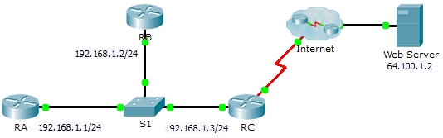

1. Addressing Table

|  |  |  |  |
| --- | --- | --- | --- |
| Device | Interface | IP Address | Subnet Mask |
| RA | G0/0 | 192.168.1.1 | 255.255.255.0 |
| RB | G0/0 | 192.168.1.2 | 255.255.255.0 |
| RC | G0/0 | 192.168.1.3 | 255.255.255.0 |
| S0/0/0 | 209.165.200.225 | 255.255.255.252 |

1. Scenario

In this Skills Integration Challenge, your focus is OSPFv2 advanced configurations. IP addressing has been configured for all devices. You will configure OSPFv2 routing with passive interfaces and default route propagation. You will modify the OSPFv2 configuration by adjusting timers and establishing MD5 authentication. Finally, you will verify your configurations and test connectivity between end devices.

1. Requirements

* Use the following requirements to configure OSPFv2 routing on **RA** and **RB**:
  1. OSPFv2 routing requirements:

Process ID 1

Network address for each interface

Enable authentication for area 0

* 1. OSPF priority set to 150 on the LAN interface of **RA**
  2. OSPF priority set to 100 on the LAN interface of **RB**
  3. OSPF MD5 authentication key ID of 1 and MD5 key “cisco” on the LAN interfaces of RA and RB
  4. Set the hello interval to 5
  5. Set the dead interval to 20
* Use the following requirements to configure **RC** OSPFv2 routing:
  1. OSPFv2 routing requirements:

Process ID 1

Network address for the LAN interface

Enable authentication for area 0

Set all interfaces to passive by default, allow OSPF updates on the active LAN

Set the router to distribute default routes

* 1. Configure a directly attached default route to the Internet
  2. OSPF priority set to 50 on the LAN interface
  3. OSPF MD5 authentication key ID of 1 and MD5 key “cisco” on the LAN interface of **RC**
  4. Set the hello interval to 5
  5. Set the dead interval to 20

**Note:** Issue the **clear ip ospf process** command on **RC** if the default route does not propagate.

* Verify your configurations and test connectivity
  1. OSPF neighbors should be established and routing tables should be complete.
  2. **RA** should be the DR, **RB** should be the BDR.
  3. All three routers should be able to ping the web server.